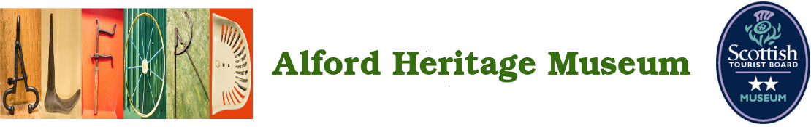
2026 SPONSORSHIP PACKAGE DETAILS

Museum sponsors are offered a wide range of benefits.

Event sponsorship packages vary and can be discussed in further detail alongside our event list with any interested parties.

For any additional queries or to register as a sponsor please contact
sponsorship@ahm.org.uk

General Sponsors: £100

Gold Sponsors:
£250

Platinum Sponsors:
£500

Event Sponsors:
£500+
General Sponsors are listed on the Alford Heritage Museum website and on the sponsors board at the entry to the museum.
General Sponsors will be invited to our annual museum supporters’ event.
General sponsors will be included in our Members Newsletters

Gold Sponsors will receive the same benefits as General Sponsors, plus the following: One seasonal ticket to be used for free access to the museum during regular public hours or events not requiring advanced tickets.

Platinum Sponsors will receive the same benefits as Gold Sponsors, plus the following: Two free tickets to an event of their choice. Platinum Sponsors will be offered a space for their logo or business name on any seasonal promotional materials printed after they become a sponsor.

Event Sponsors will receive the same benefits as Platinum Sponsors plus the following: Four free tickets to an event of their choice, marketing or retail presence at their sponsored event inclusion in event specific promotions including press releases

